The Willows School Academy Trust



Reviewed: September 2026
Next Review: September 2027

Our policy

Our academy uniform is important to us. It is one way in which we identify ourselves as a school community and it promotes a strong and cohesive identity, which supports high standards in all areas of school life. Our uniform policy reflects our values and reinforces our culture of high expectations, pride in our appearance and academic achievements. It promotes harmony between different groups in the school and enhances self-esteem and a sense of personal security.

The Willows School Academy Trust uniform unites the Willows community and supports equality – whether families have high incomes or low incomes everyone wears the same. Our students develop a sense of pride in how they present themselves and the importance of being ready to work.

1. Equality and equal opportunities

1.1 All children have equal access to wearing the school uniform regardless of their culture, race, religion, gender, disability or ability. Our uniform is gender neutral. We ensure that the set uniform respects other policies such as equality, race relations, sex discrimination and allows for individual sets of circumstances for all groups and individuals. The Willows School Academy Trust is committed to creating a positive climate that will enable everyone to work free from discrimination and harassment in order to achieve their full potential. Consideration has been given to how the uniform can be adapted for those who have a disability or who wish to express a cultural, religious or racial identity within the framework of the Willows whilst fostering cohesion, safety and a sense of community.

1.2 We will do all we can to ensure that this policy does not discriminate, directly or indirectly. We shall do this through regular monitoring and evaluation of our policies. On review, we shall assess and consult relevant stakeholders on the likely impact of our policies on the promotion of all aspects of equality, as laid down in the Equality Act (2010). This will include, but not necessarily be limited to: race; gender; sexual orientation; disability; ethnicity; religion; cultural beliefs and pregnancy/maternity. We will use an appropriate Equality Impact Assessment to monitor the impact of all our policies and the policy may be amended as a result of this assessment.

2. Expectations

We have taken care to ensure that our uniform is affordable and to minimise the number of items that need to be purchased from a particular supplier. Items marked as such must be purchased from our supplier and parents should take care when buying other items to ensure that they meet our expectations.

3. Uniform

The uniform expectation is maintained all year round. Students will be expected to wear a blazer, white polo shirt or long-sleeved shirt (weather dependent), school tie and black and grey trousers/skirt.

• School Blazer
• White shirt, must be tucked in
• School Tie
• Black or Grey trousers trousers/skirt
• Sweater vest
• Plain black smart shoes: No trainers or boots. Laces must be black. No heels, if unsure contact your child’s teacher prior to purchasing.
• Hats. Gloves. Scarves must be blue in colour (must be removed in class)
• Pupils are allowed to cover their head for religious or cultural reasons, they must be plain dark colours and without decoration or embellishment
• Religious symbols or other attire can be worn if needed
• No makeup, false nails or nail varnish.

PE Kit (example, may depend on sports played)

• Willows blue polo T-shirt (provided by the school)
• Students can wear a plain black or white long sleeve top underneath if they wish to.
• Plain black tracksuit bottoms, no logos or stripes OR black shorts. No cycling shorts.
• Plain black leggings can only be worn if black shorts are worn over the top.
• Sports trainers, no flat soles e.g. converse/vans are not permitted.

4. Hairstyles, headscarves and headwear

The Willows School Academy Trust is a diverse community. We recognise that different cultures prescribe different levels of importance to hairstyles, hair colouring and headwear. The Willows approach is designed to recognise this, whilst ensuring that there are clear boundaries, and a professional ethos in the school. Pupils’ faces should not obscured or covered, so that the teacher can judge their engagement with learning and their participation in discussions and practical activities.

4.1 Hair

Pupils’ hair should be neat and/or tied back for health and safety. Hair accessories must be subtle and in Willows colours.

If pupils are unsure whether a hairstyle meets the school policy they should check in advance with the school.

5. Hats, headscarves and head coverings

Hats, headscarves and head coverings are permitted for religious or cultural reasons and should be navy or black.
Pupils are not allowed to wear hats, headscarves or any other head covering inside the school building unless it is due to religious or cultural reasons.

Students’ faces should not obscured or covered, so the teacher can judge a pupil’s engagement with learning and participation in discussions and practical activities.

6. Jewelry/Accessories

Pupils may not wear any jewelry except for the following:

• one watch (no sound effects, games or smart watches).
• Pupils are allowed to wear plain stud earrings. These should not be bigger than the lobe.
• A Kara may be worn for religious reasons.
- Accessories that are seen to be contravening these rules will be confiscated
• The Willows will be unable to take any responsibility for any watches or jewelry that are lost.

7. Purchasing the uniform

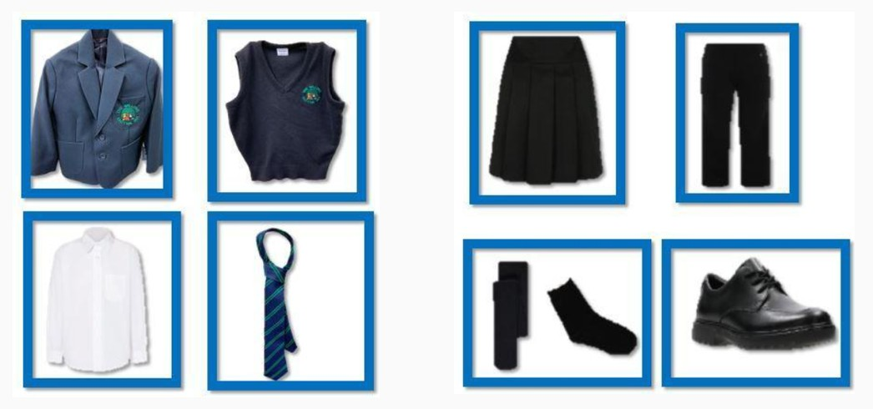

Items for Purchase at The Willows | Not Available for Purchase
Blazer £30.00 | Black or Grey Trousers or shorts
Tie: £5.00 | Black Shoes (not trainers)
Sweater Vest: £15.00 | White Long-Sleeved Shirt or
Book Bag £5.00 | White Polo Shirt

7.1 Special circumstances

There are very few reasons why a pupil should not be wearing the Willows uniform. If there are extenuating circumstances, parents and carers should share the reason with their child’s teacher, either in person or by phone. The Willows will always be considerate and discrete in trying to establish why a pupil is not wearing the correct uniform. Pupils will not be made to feel uncomfortable, nor discriminated against, because their parents/carers are unable to provide them with the required items of the school uniform. In line with our ethos, we encourage discussion with the school at the earliest opportunity if there are any difficulties, financial or personal, the school has a supply of new and second-hand uniforms it can dispense in such circumstances.

Items not available for purchase at the Willows can be purchased from Tesco Extra or Sainsbury’s supermarkets. If there is difficulty in either affordability or inability to purchase these items, please speak to a member of staff.

There will be occasions when the Willows decides that the uniform is not appropriate, for instance when wearing different clothes due to a fundraising event or due to extreme weather. Parents and carers will be notified in advance of the revised dress code on these days.

8. Naming clothing and property

Please ensure all clothing and property is clearly marked so that lost articles may be easily traced and returned. The Willows cannot accept responsibility for loss or damage to pupils’ property and valuables.
9. Equality Impact Assessment

We do all we can to ensure that this policy does not discriminate, directly or indirectly. We shall do this through regular monitoring and evaluation of our policies. On review, we shall assess and consult relevant stakeholders on the likely impact of our policies on the promotion of all aspects of equality, as laid down in the Equality Act (2010). This will include, but not necessarily be limited to: race; gender; sexual orientation; disability; ethnicity; religion; cultural beliefs and pregnancy/maternity.

